April 26, 2020 Gospel Reading and Songs

The holy gospel according to Luke. Glory to you, O Lord.

Gospel: Luke 24:13-35
¹³Now on that same day [when Jesus had appeared to Mary Magdalene,] two [disciples] were going to a village called Emmaus, about seven miles from Jerusalem, ¹⁴and talking with each other about all these things that had happened. ¹⁵While they were talking and discussing, Jesus himself came near and went with them, ¹⁶but their eyes were kept from recognizing him. ¹⁷And he said to them, “What are you discussing with each other while you walk along?” They stood still, looking sad. ¹⁸Then one of them, whose name was Cleopas, answered him, “Are you the only stranger in Jerusalem who does not know the things that have taken place there in these days?” ¹⁹He asked them, “What things?” They replied, “The things about Jesus of Nazareth, who was a prophet mighty in deed and word before God and all the people, ²⁰and how our chief priests and leaders handed him over to be condemned to death and crucified him. ²¹But we had hoped that he was the one to redeem Israel. Yes, and besides all this, it is now the third day since these things took place. ²²Moreover, some women of our group astounded us. They were at the tomb early this morning, ²³and when they did not find his body there, they came back and told us that they had indeed seen a vision of angels who said that he was alive. ²⁴Some of those who were with us went to the tomb and found it just as the women had said; but they did not see him.” ²⁵Then he said to them, “Oh, how foolish you are, and how slow of heart to believe all that the prophets have declared! ²⁶Was it not necessary that the Messiah should suffer these things and then enter into his glory?” ²⁷Then beginning with Moses and all the prophets, he interpreted to them the things about himself in all the scriptures.
²⁸As they came near the village to which they were going, he walked ahead as if he were going on. ²⁹But they urged him strongly, saying, “Stay with us, because it is almost evening and the day is now nearly over.” So he went in to stay with them. ³⁰When he was at the table with them, he took bread, blessed and broke it, and gave it to them. ³¹Then their eyes were opened, and they recognized him; and he vanished from their sight. ³²They said to each other, “Were not our hearts burning within us while he was talking to us on the road, while he was opening the scriptures to us?” ³³That same hour they got up and returned to Jerusalem; and they found the eleven and their companions gathered together. ³⁴They were saying, “The Lord has risen indeed, and he has appeared to Simon!” ³⁵Then they told what had happened on the road, and how he had been made known to them in the breaking of the bread.

The gospel of our Lord. Praise to you, O Christ.

Songs

Opening Song: 855 “Crown Him with Many Crowns”
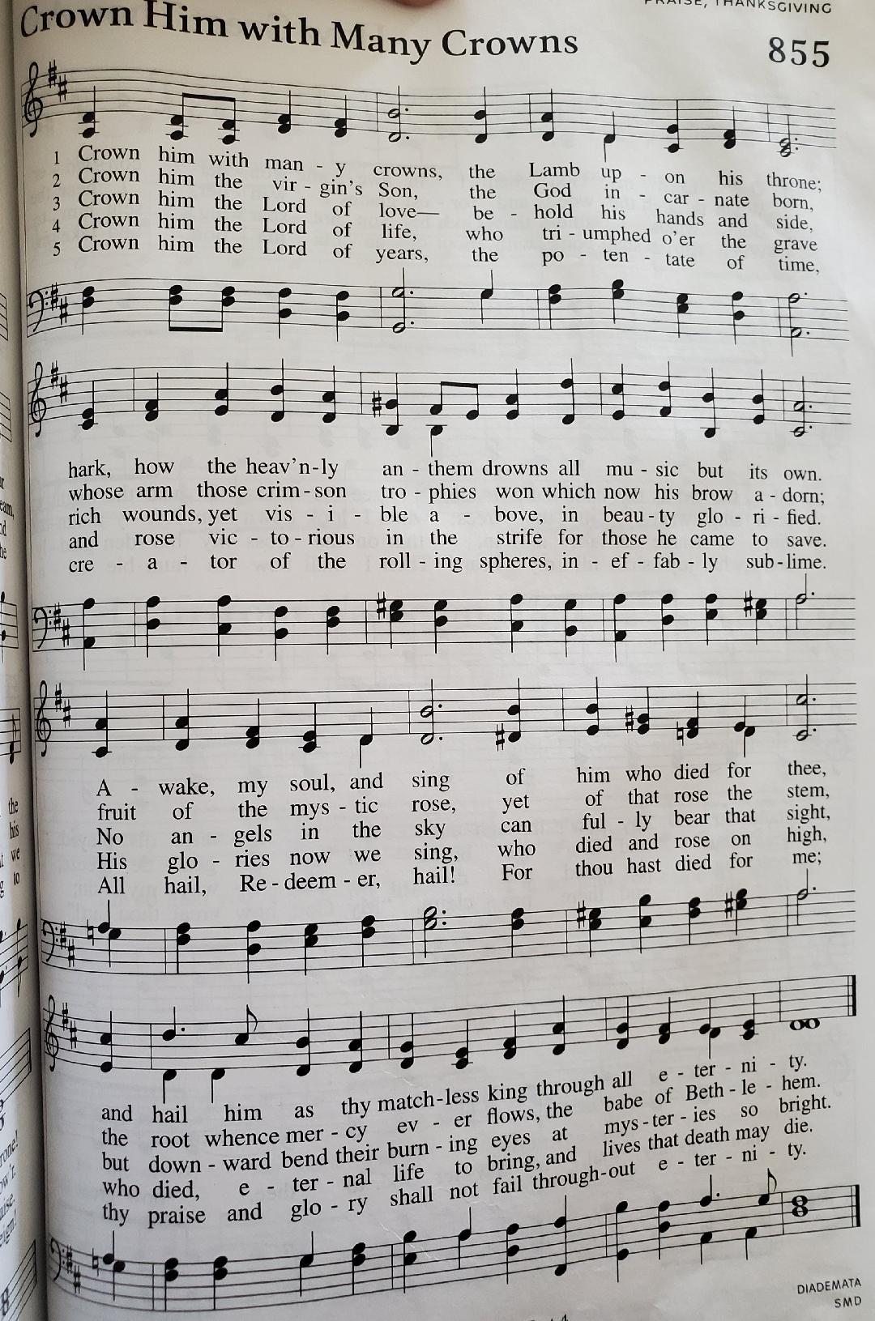

Hymn of the Day: 803 “When I Survey the Wonderous Cross”
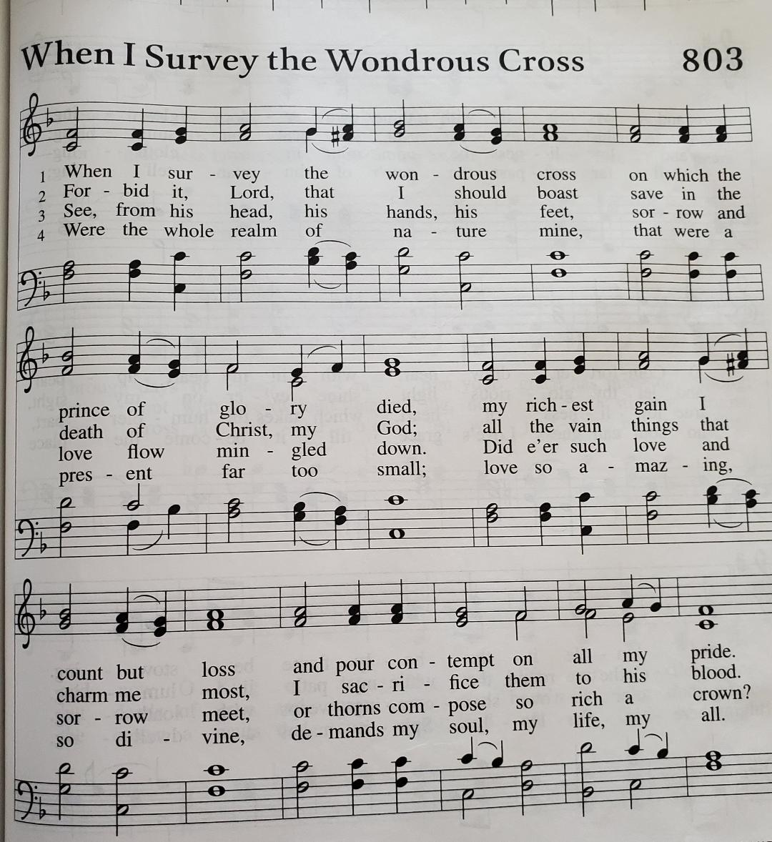

Sending Song: 885 “Praise God, from Whom All Blessings Flow”
